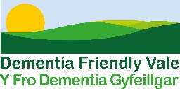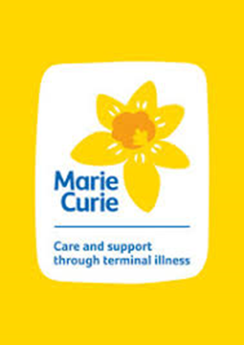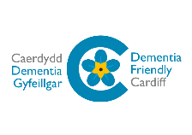

Working to become Dementia Friendly Actions

The following actions offer an example of commitments made by businesses and organisations as they work towards becoming Dementia Friendly. Please feel free to choose these actions. You can also use the free business guide created by Alzheimer’s Society to do this.

People: Training & awareness
Have a plan in place to roll out Dementia Friends sessions across your business or organisation.
Please tell us how you plan to achieve this, and your expected completion date.
----------------------------------------------------------------------------------------------------------------------------------------------------------------------------------------------------------------------------------------------------

Places: Physical Environment
Complete a self-guided accessibility audit using the environments checklist provided, and review signage throughout your premises.
Please tell us how you plan to achieve this, and your expected completion date.
--------------------------------------------------------------------------------------------------------------------------------------------------------------------------------------------------------------------------------

Processes: Supporting customers to use your service
Identify ways of supporting customers living with dementia to use your service more easily, i.e. being supported to make a purchase or payment
Please tell us how you plan to achieve this, and your expected completion date.
----------------------------------------------------------------------------------------------------------------------------------------------------------------------------------------------------------------------------------------------------

Processes: Information provision & signposting
Signpost your customers or staff who are affected by dementia to further support (i.e. Alzheimer’s Society’s Dementia Connect support line on 0333 150 34560).
Please tell us how you plan to achieve this, and your expected completion date.
----------------------------------------------------------------------------------------------------------------------------------------------------------------------------------------------------------------------------------------------------

*You may also want to discuss with your colleagues how your business or organisation can raise awareness about dementia internally and in the wider community (i.e. publishing Dementia Friendly content on your intranet, website, and/or social media feeds).

Please contact DementiaFriendlyOrganisations@mariecurie.org.uk if you would like further information or require additional support.

